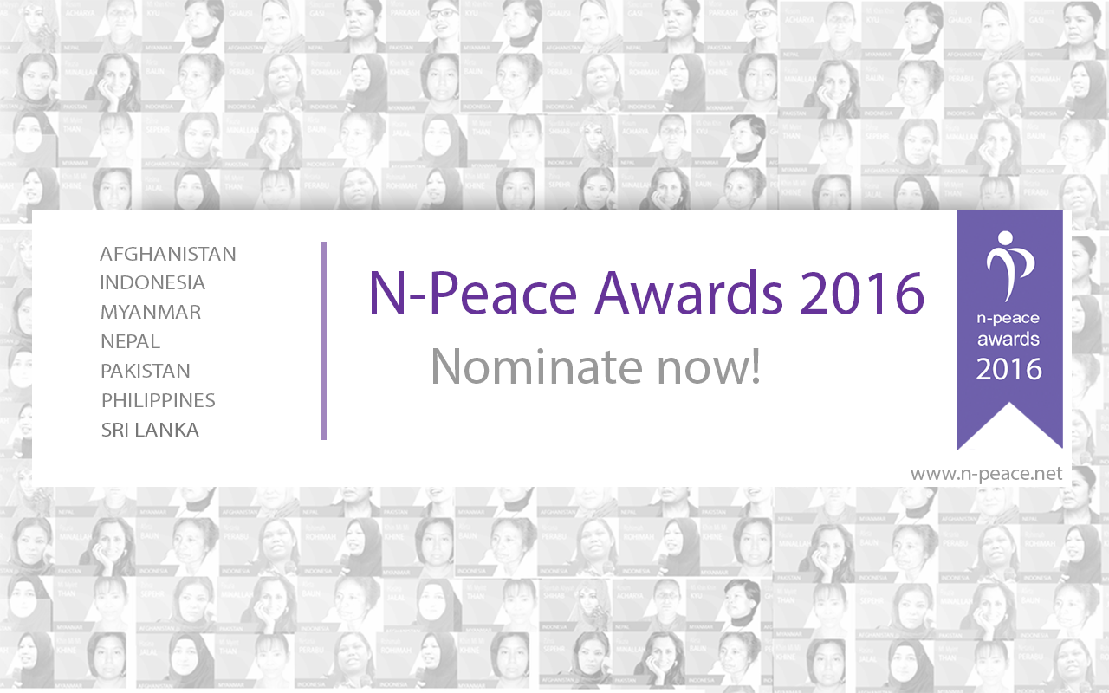
ABOUT YOUR NOMINEE
 |  |  | M | F
First name of nominee |  | Last (Family) name of nominee | Sex
Country of nominated candidate |  | Email of nominee
Phone number |  | Category (Untold Stories/Campaigning for Action/Peace Generation)
Age of Nominee (or Date of Birth)

ABOUT YOURSELF AS THE NOMINATOR
Your first name |  | Your last (family) name
Country of residence |  | Email
Phone number |  | Your relationship with the nominee (how do you know them: family/colleague/friend)

In the space below write a profile about the nominee and their work. You should provide examples of their work for peace. If you would like to read some example profiles from previous years’ awardees please go to: http://n-peace.net/alumni/2015. You can also attach the nominee profile as a separate document when you email this form.

Nominee Profile:

IMPORTANT INFORMATION
To complete your nomination you need to:
1. Fill in this form and email it to n-peace@undp.org:
2. Attach a photo file to the email. The photo needs to be a headshot of the nominated candidate. We just require the image to include the candidate's shoulders and head so we can use this during the campaign period of the N-Peace Awards. The photo should be no less than 240KB must not exceed 1MB. The photo should be a JPG or PNG file.
3. If you have supporting documents you would like to include with the nomination (such as a CV or a newspaper article), please also attach them to the emailed nomination.
4. You will receive a confirmation email once your nomination has been received. If you do not receive confirmation please contact n-peace@undp.org.
Terms and Conditions:
The N-Peace Awards 2016 is an independent, public, non-monetary award in recognition of local public service selected in agreement with the United Nations Development Programme (UNDP) herein referred to as the 'partner':
The Nominators
• Any person may nominate candidates for any category of the N-Peace Award.
• It is the nominator's duty to inform the nominee of their nomination and associated terms before submitting their nomination.
• Nominators must provide all relevant and necessary information about the candidate – including adequate information for a biography and an image of the candidate – or the nomination may be rejected.
• Self-nominations are not accepted.
The Partner
• The Partner is responsible for receiving the nominations, reviewing them, publishing them and overseeing the voting process.
• The Partner reserves the right to review all the nominations received and may refuse to publish nominations that are deemed to be incomplete, inaccurate or which may to cause offense to others.
• The Partner is responsible for facilitating and overseeing the process of voting, but cannot be held responsible for the final results.
The Process
• Nominators will not be allowed to withdraw their nominee from the process, once the voting has commenced.
• Nominations for an N-Peace Award will be accepted until 15 July, 2016.
• The partner will be monitoring the voting process and reserves the right to check, verify, and disqualify votes to any nominee total tallies where the source is not genuine.
• Seven women will be announced as winners for the Untold Stories category, one from each of the seven participating N-Peace Network countries. For Campaigning for Action and Peace Generation, one woman and one man will be announced as winners.
The Award
• All winners will be invited to attend a special event held in Dec 2016 in association with UNDP. Details to be announced in due course.
• Further information about the award will be released in due course.
Other conditions
• Under no circumstances will the N-Peace Award's partners be held liable for any loss or damages incurred as a result of participation in the N-Peace Awards.
• Information submitted as part of the N-Peace Awards is governed by the Creative Commons 3.0 BY License. Under this license, the partners may copy, distribute or transmit the work; adapt the work; and make commercial use of the work.
• Staff members from the partner organization, UNDP, are not eligible to be nominated for an N-Peace Award in any category, but are eligible to nominate candidates for all award categories.

